1. Write a C++ program to create a pointer to an integer and display its value.

Program :

#include<iostream>

using namespace std;

int main()

{

int a;

cout << "Enter a number : ";

cin >> a;

int \*b;

b = &a;

cout << "Number : " << \*b;

return 0;

}

Output :

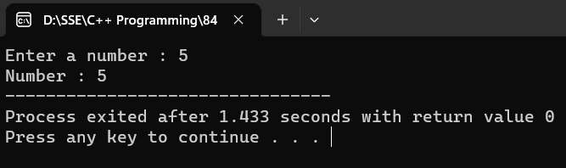

1. Write a C++ program to create a pointer to a float and display its value.

Program :

#include<iostream>

using namespace std;

int main()

{

float a;

cout << "Enter a floating number : ";

cin >> a;

float \*b;

b = &a;

cout << "Number : " << \*b;

return 0;

}

Output :

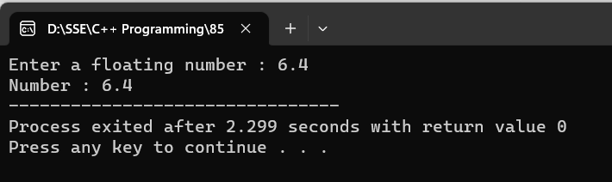

1. Write a C++ program to create a pointer to a double and display its value.

Program :

#include<iostream>

using namespace std;

int main()

{

double a;

cout << "Enter a number : ";

cin >> a;

double \*b;

b = &a;

cout << "Number : " << \*b;

return 0;

}

Output :

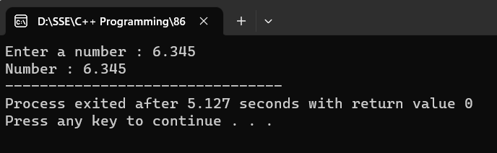

1. Write a C++ program to create a pointer to a char and display its value.

Program :

#include<iostream>

using namespace std;

int main()

{

char a;

cout << "Enter a character : ";

cin >> a;

char \*b;

b = &a;

cout << "Character : " << \*b;

return 0;

}

Output :

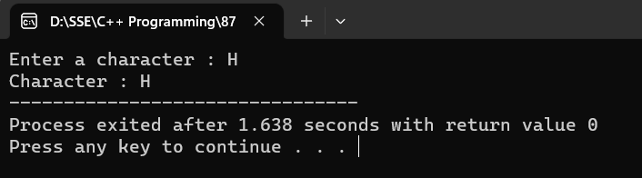

1. Write a C++ program to create a pointer to a string and display its value.

Program :

#include<iostream>

#include<string>

using namespace std;

int main()

{

string a;

cout << "Enter a string : ";

cin >> a;

string \*b;

b = &a;

cout << "String : " << \*b;

return 0;

}

Output :

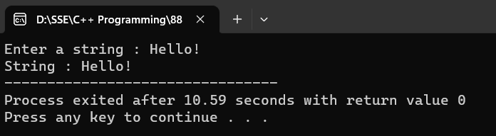

1. Write a C++ program to create a pointer to an array of integers and display its values.

Program :

#include<iostream>

using namespace std;

int main()

{

int n;

cout << "Enter the size of the array : ";

cin >> n;

int a[n],i;

cout << "Enter elements : ";

for (i=0;i<n;i++)

{

cin >> a[i];

}

int \*p;

p = a;

cout << "Array : ";

for (i=0;i<n;i++)

{

cout << \*(p+i) << " ";

}

}

Output :

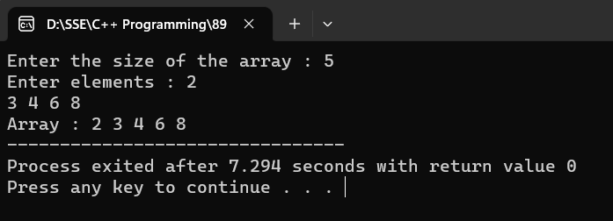

1. Write a C++ program to create a pointer to an array of characters and display its values.

Program :

#include<iostream>

using namespace std;

int main()

{

int n,i;

cout << "Enter the size of the array : ";

cin >> n;

char a[n];

cout << "Enter characters : ";

for (i=0;i<n;i++)

{

cin >> a[i];

}

char \*p;

p = a;

cout << "Array : ";

for (i=0;i<n;i++)

{

cout << \*(p+i);

}

}

Output:

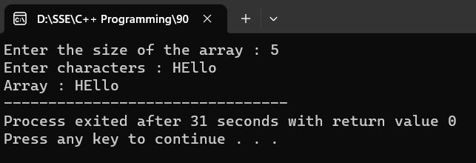

1. Write a C++ program to create a pointer to an array of floats and display its values.

Program :

#include<iostream>

using namespace std;

int main()

{

int n,i;

cout << "Enter the size of the array : ";

cin >> n;

float a[n];

cout << "Enter elements : ";

for (i=0;i<n;i++)

{

cin >> a[i];

}

float \*p;

p = a;

cout << "Array : ";

for (i=0;i<n;i++)

{

cout << \*(p+i) << " ";

}

return 0;

}

Output :

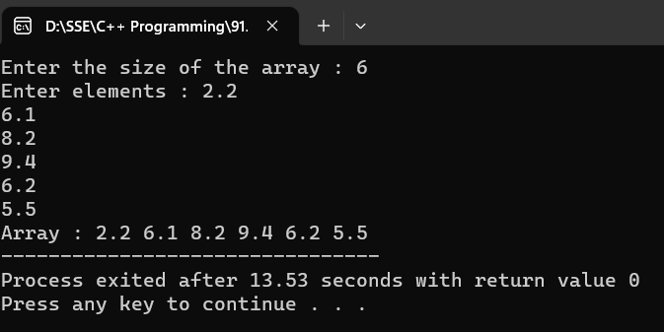

1. Write a C++ program to create a pointer to an object and display its attributes.

Program :

#include<iostream>

using namespace std;

class A {

public:

int a;

A()

{

cout << "Enter a number : ";

cin >> a;

}

};

int main()

{

A A1;

A \*p;

p = &A1;

cout << p->a;

return 0;

}

Output :

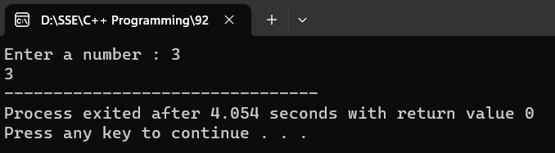

1. Write a C++ program to create a pointer to a function and call the function using the pointer.

Program :

#include<iostream>

using namespace std;

class A {

public:

int a;

A()

{

cout << "Enter a number : ";

cin >> a;

}

void display()

{

cout << a;

}

};

int main()

{

A A1;

A \*p;

p = &A1;

p->display();

return 0;

}

Output :

